Name: Mohamed Ahmad khalil al tawil
University number: 320210601141
Web 2 : lab 2

Task 2: Basic JavaScript:
- Welcome message:

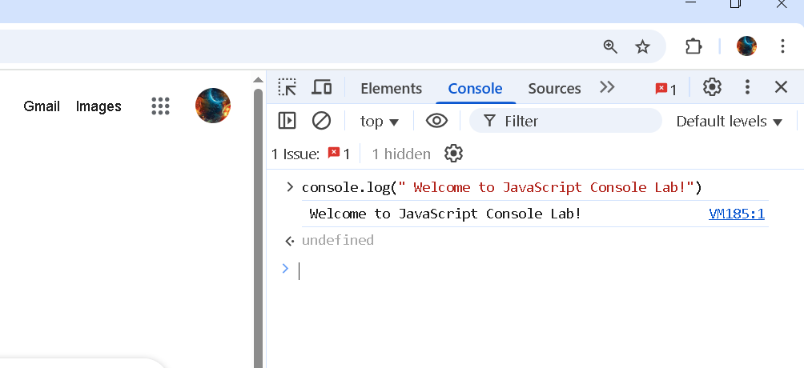

- Dynamic Variables :

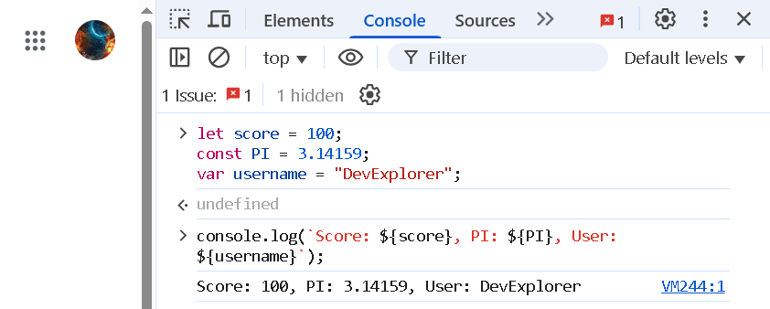

Task 3: Logic & Control Flow:
1-Conditional Checks:

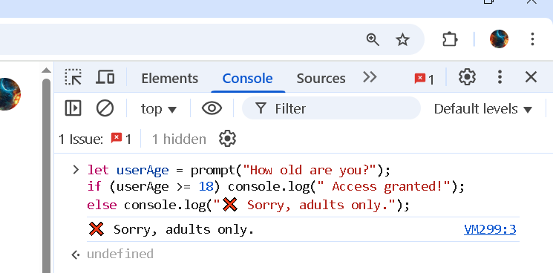

2-Switch-Case :

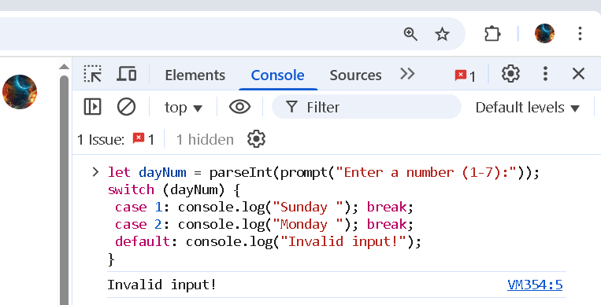

- Loops: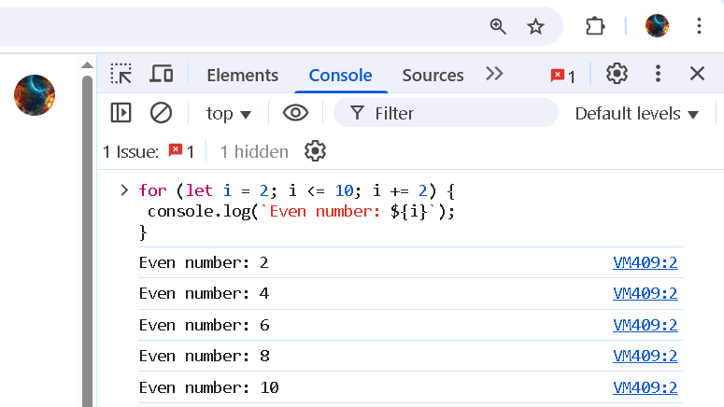
Task 4: Collections:
- Arrays:

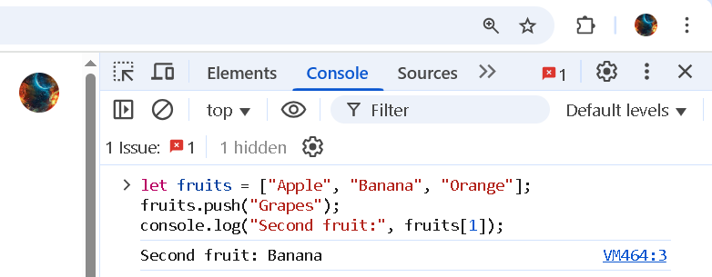

2:Maps:

